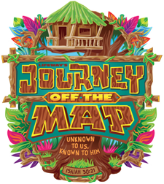
VACATION BIBLE SCHOOL
HARVEST BAPTIST CHURCH
REGISTRATION FORM

Child’s Name: (Last)_____________________________(First)___________________________
Name of Parent (s) or legal guardian: _______________________________________________
Students date of birth: _______________ Age: ________ Last Grade Completed: ___________
Address: ______________________________________________________________________
Cell Phone: ___________________ Alternate Phone number:____________________________
Emergency Contact: __________________________ Phone: ____________________________
Relationship: __________________________
Please list any allergies your child may have: ____________________________________________________________________________________________________________________________________________________________

During VBS my child may be picked up by:__________________________________________
Does Your Child go to Church anywhere? YES NO If So Where? ______________________
T-Shirt Size: _______
HBC has permission to photograph my child: YES NO
HBC has permission to use these photographs as promotional material: YES NO
My Child has permission to attend VBS at Harvest Baptist Church: YES NO
Signature of Parent and or Guardian: ____________________________________ Date:________________

